Clemson University

Structure from Motion
Assignment 6, ECE 877
Ujwal C Naik
Assignment Number 6

Report for the 6th assignment for Computer Vision – ECE 877.

Introduction:
In this assignment we have Structure from Motion using the Tomasi-Kanade factorization which is an SVD based factorization scheme for analyzing the image measurements of a rigid object captured from different views using a weak perspective camera model. The idea being that if all the measurements (that is all the image coordinates of all the points in all views) are collected together in a single matrix, the point trajectories will reside in a single subspace.

Method:
The method followed for implementation of structure from motion is as follows:
- Track the points: The feature points/points of interest are tracked through several image frames to determine the location of the point in different frames. For this purpose we have used the KLT tracker. However for the cube sequence manually calculated correspondences were used.
- Prepare the feature coordinate matrix: All the features are placed in a single matrix since, placing all the measurements in the same matrix means that the point trajectories will all reside in the same single subspace. This matrix is called the feature matrix W and it contains 2xF rows and P columns. Where F is the number of frames and P is the number of features.
- Calculate Wcap: We subtract the mean of each row from every element in the feature matrix to obtain the Wcap matrix.
- Calculate the SVD of Wcap: Since Wcap is a wide matrix we have to transpose it before calculating the SVD of the matrix. Due to this transposition we need to interchange the position of the U and V matrix.
- Calculate U3 and V3: we take the first three columns and the first three rows of U and V respectively to get U3 and V3 matrices.
- Create an initial guess for Rotation(R) and Shape(S) : We create a random estimate of the rotation and shape using the formulae given.
- Calculating the C matrix: The C matrix is calculated by using least squares to solve the equation formed by imposing the metric constraints.
- Calculating the Q matrix: Once the C matrix has been calculated, the Q matrix can be found using the SVD of the C matrix and the given formulae.
- The final scene structure is then obtained by multiplying the inverse of the Q matrix with the matrix used to make an estimate of the shape.

Algorithm:
The algorithm for top-down view transformation is as follows:
- Track the correspondences using the KLT tracker and note the features that are not lost during the process of tracking. Save the coordinates of the features that have been tracked successfully through all the frames.
- Put the feature coordinates into a matrix that has 2F rows and P columns – W, where F is the number of frames and P is the number of tracked features.
- Calculate Wcap using the average of each row of W and subtracting it from each element of the matrix W.
- Compute the SVD of the Wcap matrix by transposing it(if it is a wide matrix).
- Using the results of SVD calculate initial guess of Rotation(Rcap) and Shape(Scap).
- Using the given formulae calculate the C matrix by using least squares.
- Find the Q matrix using the C matrix.
- Use the inverse of the Q matrix along with the initial guess of the shape of the object to obtain the structure of the scene.

RESULTS
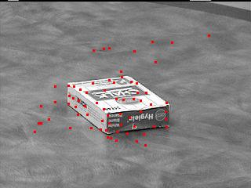
Result of feature tracker.
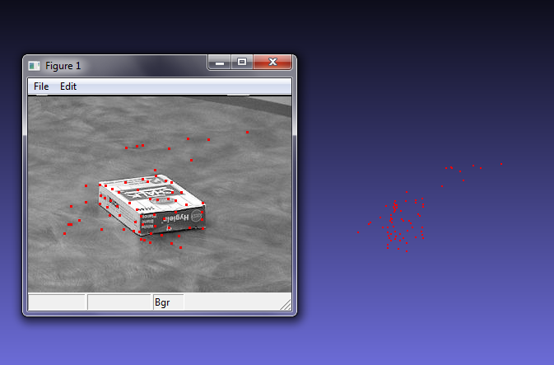
Result in meshlab.
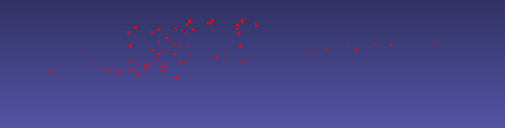
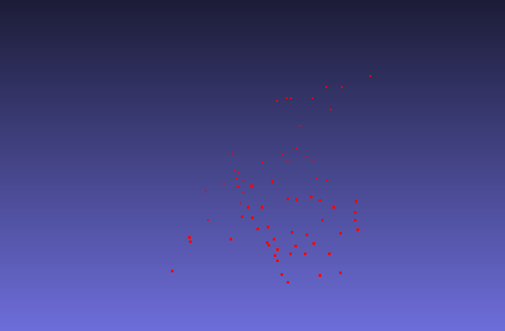

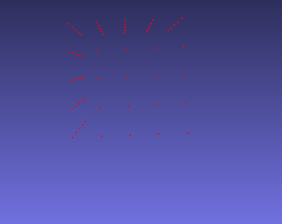
Result for cube

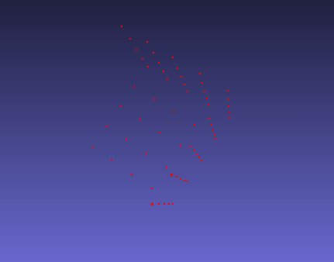
Result for cube.

Conclusion
It can be observed from the results that the algorithm allows us to create reasonable 3 dimensional representations of the object that is being tracked in the image. The parts of the cube that were tracked have been reconstructed perfectly whereas the results are not as good for the chalk sequence due to noise in tracking the points of interest (i.e. the points are not accurately tracked all the time).
This method is very useful in 3 D reconstruction of indoor and outdoor scenes it can also be used to build high quality 3D models using only pictures which would also save a lot of time and effort.
.
.

